2026 Static CPD Application Form

This static application form is designed to help you gather essential information for your online CPD application. It facilitates collaboration with your professional educational activity team, enabling you to identify roles and contributions to ensure your application is both compliant and complete. If you require any assistance during the application process, the AIcpdS team is always available to support you.
Please list the responsible person for this CPD Accreditation/Verification application
First name
Last name
Company Name
Job Title
Email
Mobile Number
State or Territory

Official Applicant
Important Notice: This application must include comprehensive details and supporting documentation to enable the adjudication and peer review teams to fully understand the scope of the activity. Failure to provide sufficient information may res‐ult in submission rejection and limitations on future applications.
By checking the 'I agree' box below, you confirm that you are the designated Official Applicant (OA). As the OA, you are ac‐countable for overseeing the accreditation application and must verify that all submitted details are accurate and up to date at the time of submission and upon accreditation approval, the activity is delivery as intended in your application.
☐ I agree that I am the Official Applicant and the accountable person for this application

Level of CPD review for your activity
CPD Accreditation
The formal recognition that the activity meets established quality standards set by the authoritative body. It is a process of assessment and validation to ensure competence, credibility, and compliance with industry or regulatory requirements.
Application for accreditation involves an additional process of assessment including independent peer review. It is purposed for corporate industry produced content, and healthcare service providers producing education for referral engagement to demonstrate content is free of marketing, high quality, and compliant.
CPD Verification
The process of checking, confirming, or validating that the activity meets specific requirements, standards, or truthfulness. It involves gathering evidence to ensure accuracy, authenticity, or compliance.
Application for verification does not involve independent peer review. It is ideal for non-clinical content or industry Associations/Organisations with experienced subject matter experts.
CPD Re-review
The process of checking, confirming, or validating that an activity is still relevant and continues to meet specific requirements and standards for compliance.
Application for re-review is ideal for annual updates and to demonstrate currency and continued relevance to learners and generates an updated trust mark.
Please select the level of CPD you applying for
☐ CPD Accreditation
☐ CPD Verification
☐ CPD Re-review

Please indicate the length of your activity
☐ 0-1 hours of learning
☐ 1-3 hours of learning
☐ 3-6 hours of learning
☐ Multiple Day Activity

Scope of Practice of intended learners
The application fee includes one primary scope of practice. However, interprofessional learning activities may involve additional scopes. Please list all scopes of practice relevant to your CPD application below.
Note: Each additional scope of practice incurs an extra fee of $275 + GST to be invoiced. Clinical content must align with at least one specific scope of practice, while non-clinical content i.e. 'Leadership skills' or 'Cyber Security' may satisfy a broader scope i.e. 'Healthcare Professional’ or ‘Healthcare Provider’
☐ General Practitioner | ☐ Dentist
☐ Nurse/Midwife | ☐ Pharmacist
☐ Physician | ☐ Social Worker
☐ Surgeon | ☐ Medical Practitioner (when applicable)
☐ Paramedicine | ☐ Physiotherapist
☐ Occupational Therapist | ☐ Medical Radiologist
☐ Psychiatrist | ☐ Chinese Medical Practitioner
☐ Psychologist | ☐ Aged Care Worker
☐ Chiropractor | ☐ Audiologist
☐ Osteopath | ☐ Disability Worker
☐ Podiatrist | ☐ Pathologist
☐ Vet | ☐ Other
☐ Aboriginal and Torres Strait
Islander Health Practitioner

Options for non-clinical content only
☐ Healthcare Practitioner non-clinical content
☐ Healthcare Provider non-clinical content
☐ Practice Owner non-clinical content
☐ Practice Management non-clinical content

Activity Design and Delivery Planning
What is the Title of your educational activity?

What is the Aim of your activity?
This should be a concise statement outlining the main objectives of the activity; much like an invite blurb.

Please select the Mode of Delivery for your activity:
☐ Face-2-Face (meeting/conference/workshop)
☐ Digital Delivery (webinar/podcast/on-demand/e-Learning)
☐ Audit Tool
☐ Subject Matter Expert (SME) recognition of learning through teaching
☐ Research
☐ Hybrid/Blended (please specify combination in 'other')
☐ Work-based and Supervised Learning (placements/rotations/supervision programs)
☐ Assessment and Evaluation (including Professional Development Planning)
☐ Other
Indicate the Frequency of your activity;
☐One time event
☐ Series (same learners, progressive content)
☐Repeated (same content, different learners)
What is the estimated Number of participants for your activity?
*It is important to remember, deep learning experiences requires smaller participant: facilitator ratio

What date do you plan for your activity to start?
*Use first session date for activities within an educational series
Commencement Date /01/2026

Subject Matter Experts (SME)
Activities are required to have active input from a SME within the scope of practice of the intended learner to ensure relevancy and currency of learning. List all SMEs involved in the activity content build, review, and facilitation of delivery.
Name | Roles/Specialty | Email | Principle place of practice | AHPRA number  (if applicable)
Add rows if needed

Core Units
Our Standards ensure compliance with national regulations. Activities must demonstrate at least one of following Core Units recognised by the PACE framework.
PACE may also be known as CAPE across industry.
☐ Professionalism
☐ Addressing health inequities
☐ Culturally safe practice, and
☐ Ethical practice

Learning Focus Areas
PACE Professionalism
☐ Professional development in skills, knowledge, behaviours and attitudes Development in technical skill and expertise, ethical mindset, and critical thinking abilities necessary to provide high-quality patient care. The development of these competencies involves structured learning, experiential practice, and continuous self-reflection
☐ Communication Skills Verbal, Non-Verbal, and Written Communication Mastering clear, professional, and empathetic communication across all mediums, including patient interactions, interprofessional collaboration, and clinical documentation.
☐ Interprofessional Collaboration Fostering teamwork among healthcare professionals to ensure coordinated and effective patient care, while respecting diverse roles and expertise.
☐ Leadership and Organisational Management Healthcare Leadership and Governance Cultivating leadership skills to guide healthcare teams, uphold ethical standards, and oversee the delivery of high-quality, patient-centred care.
☐ Strategic Development and Operational Planning Crafting and implementing strategic initiatives that align with healthcare goals, enhance efficiency, and improve patient outcomes.
☐ Continuous Quality Improvement Applying methodologies to assess, refine, and optimise healthcare services, incorporating self-reflection and evidence-based practice.
☐ Financial and Workforce Management Budgeting and Financial Stewardship Understanding healthcare economics to ensure sustainable financial management, resource allocation, and cost-effective service delivery.
☐ Workforce Development and Well-being Addressing staff recruitment, retention, role clarity, and professional growth while integrating mental health support and first aid for healthcare teams.
☐ Practitioner Well-being and Self-Care Sustainable Health and Well-being Strategies Developing daily habits that support mental and physical well-being, increase resilience, and enhance professional productivity. Incorporates mental health first aid and strategies to prevent burnout.
☐ Work-Life Balance and Stress Management Cultivating techniques to balance professional responsibilities with personal life, ensuring long-term career satisfaction and overall well-being.
☐ Career Development and Future Planning Professional Growth and Skill Development Identifying opportunities for ongoing education, specialisation, and career advancement while maintaining a sustainable work-life balance.
☐ Leadership Transition and Succession Planning Preparing for future leadership needs by fostering emerging talent, ensuring organisational continuity, and planning for career transitions, including retirement strategies.
☐ None of the above

PACE Addressing Health Inequities
☐ First Nations Health & Culturally Safe Practices and Competency Emphasises culturally appropriate care for Indigenous communities, integrating frameworks like the Aboriginal and Torres Strait Islander Health and Cultural Safety Strategy (2020–2025).
☐ Rural and Remote Healthcare Strategies Addresses the unique challenges faced in geographically isolated areas, ensuring equitable access to essential medical services.
☐ Cultural and Linguistic Diversity (CALD) Strengthening professionals' capability to deliver inclusive, equitable, and culturally safe services for people from culturally and linguistically diverse (CALD) backgrounds.
☐ Foundations of Primary Healthcare Covers essential healthcare practices, including disease prevention, health promotion, and management of common illnesses in underserved areas.
☐ Acute and Emergency Medical Response Focuses on emergency care, trauma response, and critical care strategies vital for regions with limited immediate medical resources.
☐ Developmental Disability and Neurodiversity Focuses on enhancing professional competence in supporting people with developmental disabilities and neurodiverse profiles through inclusive, strengths-based, and person-centred practices.
☐ Psychological Well-being and Crisis Care Examines mental health concerns in remote communities, covering chronic and acute conditions, trauma-informed care, and mental health first aid.
☐ Community and Public Health Management Methods for controlling infectious diseases, environmental health risks, and broader public health initiatives in areas with limited medical access.
☐ Rehabilitative and Allied Health Professions Encompasses physiotherapy, occupational therapy, speech pathology, and other allied health services crucial for patient recovery and quality of life in rural settings.
☐ Health Policy, Advocacy, and System Reform Focuses on shaping healthcare policies, advocating for equitable access, and driving systemic improvements in healthcare delivery.
☐ None of the above

PACE Culturally Safe Practices and Competency
☐ First Nations Health & Cultural Safety and Competency Understanding the historical and contemporary effects of colonisation and their impact on First Nations health. Emphasises culturally safe practices and policies, including frameworks such as the Aboriginal and Torres Strait Islander Health and Cultural Safety Strategy (2020–2025).
☐ Effective Cross-Cultural Communication Developing verbal, non-verbal, and written communication skills that promote respectful interactions with individuals from diverse cultural backgrounds. Avoiding stereotypes and fostering trust in healthcare settings.
☐ Social and Emotional Well-being in First Nations Communities Recognising the unique mental health needs of First Nations peoples, shaped by historical trauma, cultural displacement, and ongoing discrimination. Advocating for culturally appropriate mental health support and trauma-informed care.
☐ Chronic Disease Prevention and Management Addressing high rates of chronic illnesses such as diabetes and kidney disease in First Nations populations. Implementing prevention strategies and community-centred care models.
☐ Maternal and Child Health Equity Reducing disparities in maternal and child health outcomes by improving prenatal care, early childhood development, and access to culturally appropriate maternity services.
☐ Infectious Disease Prevention and Control Managing prevalent infectious diseases such as hepatitis, respiratory infections, and sexually transmitted infections within First Nations communities through prevention, education, and targeted healthcare interventions.
☐ Advancing First Nations Health Outcomes Taking a holistic approach to First Nations healthcare, addressing systemic barriers, social determinants, and policy-driven improvements.
☐ Cultural Competency in Healthcare Practice Equipping healthcare professionals with the skills to provide culturally responsive care, ensuring respect for diverse traditions, values, and healthcare beliefs. Incorporatestrauma-informed approaches.
☐ Environmental and Public Health Challenges Addressing environmental factors such as inadequate housing, poor sanitation, and pollution that significantly impact health outcomes in First Nations communities. Promoting collaboration between healthcare providers and environmental health experts.
☐ None of the above
If you have selected any Culturally Safe Practices and Competency, describe how your activity and program addresses power, bias, racism, and health inequities:

PACE Ethics
☐ Ethical Decision-Making and Legal Responsibilities Understanding core ethical principles, including patient autonomy, informed consent, confidentiality, and professional conduct in alignment with healthcare laws.
☐ Institutional and Environmental Support Systems Organisational Frameworks and Professional Resources Enhancing knowledge of institutional support structures, ensuring healthcare professionals have access to the necessary tools, policies, and training to deliver high-quality care.
☐ Optimising Healthcare Environments Exploring strategies for designing and maintaining healthcare spaces that promote patient dignity, comfort, safety, and staff efficiency.
☐ Advocacy, Policy, and Organisational Development Health Policy Implementation and Advocacy Equipping professionals with the skills to engage in policy interpretation, advocacy, and healthcare system improvements within their scope of practice.
☐ Leading Organisational Change in Healthcare Understanding change management strategies to navigate and implement new policies, technologies, and procedures in healthcare settings effectively.
☐ Human Resource Strategies in Healthcare Covering key workforce management areas, including recruitment, professional development, staff well-being, compliance, and strategic workforce planning.
☐ Quality Assurance and Professional Growth Clinical Governance and Accountability Ensuring healthcare services meet safety, effectiveness, and quality standards while fostering a culture of transparency and continuous improvement.
☐ Learning Through Teaching Developing and maintaining a structured Continuing Professional Development (CPD) plan, with opportunities to contribute to research, curriculum development, and education delivery
☐ None of the above

Gaps Analysis and Educational Needs Report
A gap analysis is a systematic process used to identify discrepancies between current and desired knowledge, skills, or performance levels of learners. It helps educators determine what learners currently know or do versus what they should know or do based on best practices, industry standards, or regulatory requirements. You will need to upload your report in the online submission. Please use the template provided on the 'Process and Resource' tab on our website www.AIcpdS.org.au

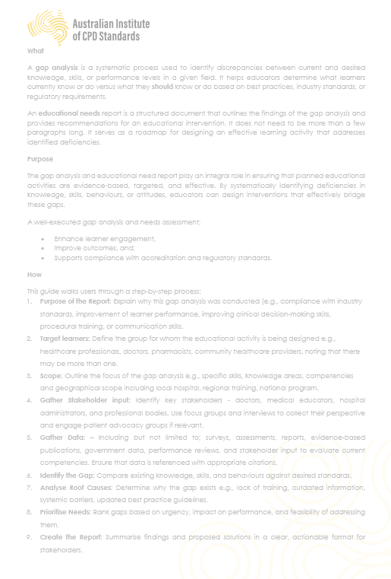

Competency Goals (Learning Outcomes)
Clearly define the specific competencies that learners will achieve upon completing the activity. These competencies should be directly tied to safety, healthcare outcomes, and professional standards. Competency Goals need to be written in bullet points using the SMART framework or equivalent:
S – Specific
M – Measured
A – Achievable
R – Relevant
T - Time-bound
*min of three competency goals

Design and Delivery Planner (With Agenda)
Design and Delivery Planner MUST be filled out using the AIcpdS Template found on the 'Process and Resource' tab on our website www.AIcpdS.org.au Other formats will not be accepted. Add columns if required.

List each session | Examples  (remove before submitting) | Session 1 | Session 2
Session Title | A General Practitioner’s review of the recently published national guidelines for the management of Cardiovascular Disease (CVD).
SME Presenter/facilitator | Name of presenter or subject matter expert involved in the content build out
Duration of the session | 90 min
Delivery Mode | webinar, face-to-face small group learning, conference, e-learning module, audit, other
Session Content  Bullet points must provide enough information for reviewers to understand the detail of content being presented.  Applications that do not provide enough information will not be approved. | - Prevalence of CVD in primary care  - The role of the GP in screening, diagnosing and long-term management of CVD  - Key recent changes to the national guidelines of CVD management  - Common screening procedures  - Optimal referral timeframes and pathways
Competency Goals for this session | Recall the recent changes in the national guidelines for the treatment and management of cardiovascular risk.
Opportunities for learner feedback and engagement including tool and resources used | Learners will be in small learning groups  Engagement with facilitators and peers to receive immediate feedback and benchmark learnings against own practices  Print out resources of current national guidelines provided  Learner activity - think/pair/share  Quiz and polls used for knowledge checks

CPD hours claim
Only include hours of learning. Do not include time allocated for registration, breaks, meals etc Increments of 15 minutes (.25 hour) can be claimed.
How many hours of Educational Activity CPD are you claiming (if any)? If you are not sure, leave blank and proceed to total hours.
How many hours of Reviewing Performance CPD are you claiming (if any)? If you are not sure, leave blank and proceed to total hours.
How many hours of Measuring Outcomes CPD are you claiming (if any)? If you are not sure, leave blank and proceed to total hours.
What are the TOTAL HOURS of CPD you are claiming?

Evaluation and Feedback
Robust learning depends on continuous improvement, making evaluation and feedback essential components of the process. It is expected that data gathered through evaluation and feedback will be shared with all stakeholders involved in the instructional design and facilitation of the activity. This ensures that insights are applied to enhance future delivery and demonstrate a clear commitment to ongoing quality improvement. Evaluation and Feedback Template found on the 'Process and Resource' tab on our website www.AIcpdS.org.au but can be provided to learners in digital or printed form.
☐ By checking this box, you are attesting that as the official applicant, all evaluation data will be shared with all stakeholders involved in the instructional design and facilitation of the activity with the intent of continuous improvement to future learning activities.
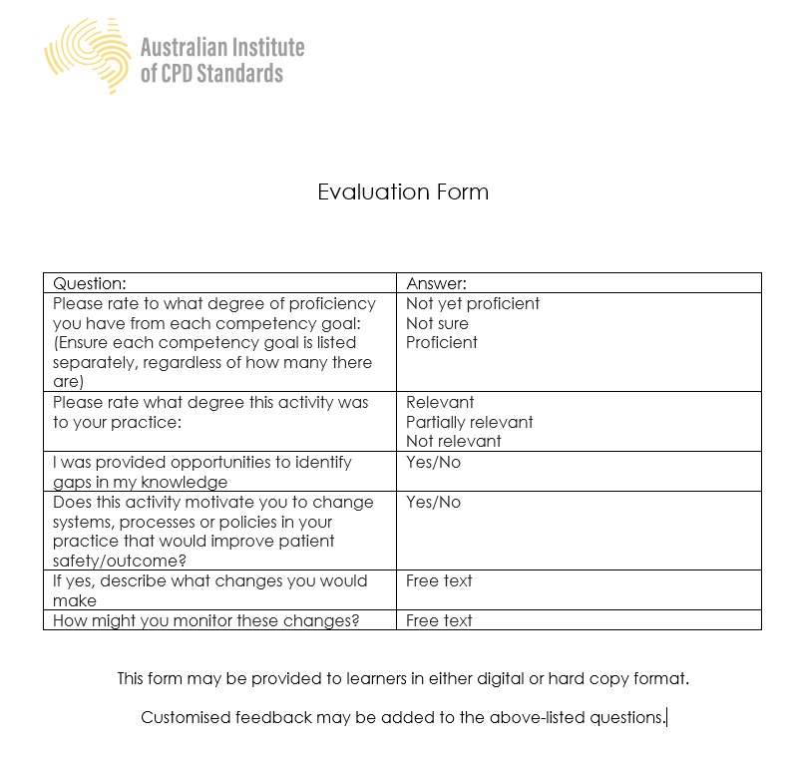

Optional Prerequisite Activity (if applicable).
If you are planning to claim CPD for a prerequisite activity for participants to complete BEFORE your activity, you must be able to evidence a record of completion. Please provide information of your Pre Activity details in Design and Delivery Planner as an additional session. You must be able to record and evidence participant completion before providing a Certificate of Completion to the participant.

Optional Reinforcing Activity (if applicable).
If you are planning to claim CPD for a reinforcing activity for participants to complete AFTER attending the activity, you must be able to evidence a record of completion. Please provide information of your Post Activity details in Design and Delivery Planner as an additional session. You must be able to record and evidence participant completion before providing a Certificate of Completion to the participant.

Sponsorship, Third Party Organisers, and potential Conflicts of Interest
List any Sponsors involved with this educational activity:
Sponsorship: where a company provides financial or other support in exchange promotional advantages. Sponsors are allowed but must have NO influence on clinical content provided to participating learners and be within compliance of industry standards.

Sponsor Name | Describe what is being provided by the Sponsor | Indicate how this sponsorship may be relevant to the commercial interests of the Sponsor

List any Third-Party Organisers or Partners involved with this educational activity:
Third-Party Organisers or Partnerships: where a company or individual partners for the activity with an agreed shared responsibility of producing the activity. All partnerships must be declared at time of application and comply with industry standards.

Third-Party Organisers or Partner Name | Describe what is being provided by the Third-Party Organisers or Partner | Indicate how this partnership may be relevant to the commercial interests of the Third-Party Organisers or Partner

☐ By checking this box, you are attesting that all sponsorship and partnership information has been declared and is accurately reflected within this application.

Official Applicant Attestation
Conflict of Interest Attestation
Your selection is an attestation that any potential or actual Conflict of Interest has been disclosed. Specifically, you affirm that neither you, as the applicant, nor anyone involved with this application is or has been engaged as a contractor to the Australian Institute of CPD Standards, either currently or in the past.
☐ There are potential Conflict of Interests
☐ There are NO known Conflict of Interests
Potential Conflict of Interest details:

It is to the best of your knowledge at the time of this application, that the information is reflective of the activity. All facilitators, third party organisers, and sponsors have been declared in this application, along with any potential conflict of interest or commercial interests and will be listed on all public communication regarding this activity.
By checking this box, I declare that the information provided is true and accurate to the best of my knowledge, and I attest to the statement above.
☐ Yes, I declare
The Australian Institute of CPD Standards is committed to protecting and respecting your privacy, and we’ll only use your personal information to administer your account and to provide the products and services you requested from us. From time to time, we would like to contact you about our products and services, as well as other content that may be of interest to you. If you consent to us contacting you for this purpose, please tick below to say how you would like us to contact you:
☐ I agree to receive other communications from Australian Institute of CPD Standards
☐ I do not agree to receive other communications from Australian Institute of CPD Standards
In order to provide you the content requested, we need to store and process your personal data. If you consent to us storing your personal data for this purpose, please tick the checkbox below. You can unsubscribe from these communications at any time. For more information on how to unsubscribe, our privacy practices, and how we are committed to protecting and respecting your privacy, please review our Privacy Policy.
☐ I agree to allow Australian Institute of CPD Standards to store and process my personal data.
☐ I do not agree to allow Australian Institute of CPD Standards to store and process my personal data.

Application Payment
Full payment is required at the time of online completion in order to finalise submission. For full fee schedule, visit www.aicpds.org.au 'FEE SCHEDULE' tab
Visit www.AIcpdS.org.au to complete your online application and make payment. We aim to finalise our processes within three weeks of application submission.

